PROJECT SUMMARY
LSNY Holdings, LLC
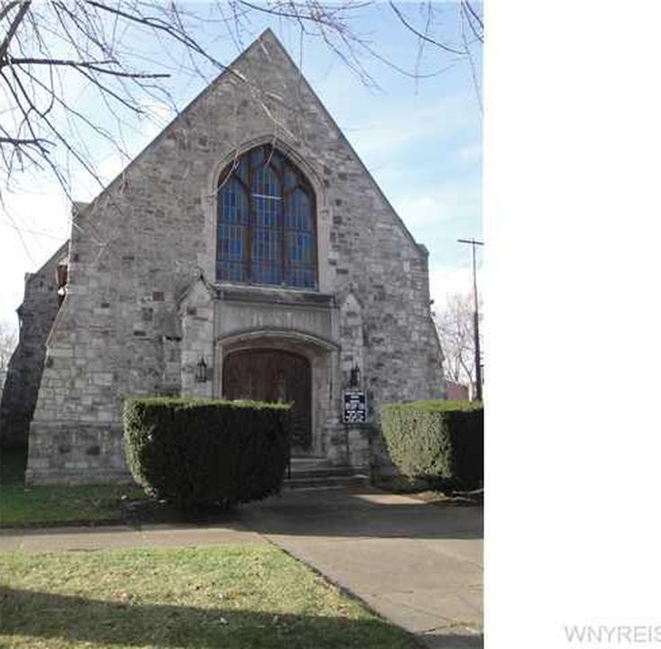

Applicant: | LSNY Holdings, LLC
Project Location: | 650 Park Place, and 545 4th St.  City of Niagara Falls, 14301
Assistance: | 10 Year PILOT, Sales Tax Exemption
Description: | Acquisition and re-purposing of a vacant church, and two houses across the street into the Museum of art and culture for Kashmir, as well as residential space for visiting artists.  The Museum will contain 600 original paintings, etchings, drawings and artifacts; the largest collection of Kashmiri art outside of Kashmir. Building 2 + 3 will be residential, to fully accommodate visiting artists, scholars and contributors.  Residents will engage via art and cultural clinics with the local community, with possible partnerships with the Rapids Theater, Niagara Arts and cultural Center and Niagara University.
Project Costs: | Construction/Improvements  Furnishings, Fixtures & Equipment  Property Acquisition  Soft costs & other  TOTAL | $ 1,250,000  $ 250,000  $ 200,000  $ 300,000  $ 2,000,000
Employment: | Current jobs in Niagara County 0  New Jobs in Niagara County within 3 years: 4  Total Annual Payroll End Year 3: $170,120  Skills: Management, Professional, Administrative, Independent Contractor
Evaluative Criteria: | Distressed Census Tract, Regional Wealth Creation, Supports Local Business or Cluster.

REGIONAL ECONOMIC IMPACT ANALYSIS
LSNY Holdings, LLC

Estimated State & Regional Benefits / Estimated Project Incentives Analysis
Total State and Regional Benefits |  | $ 334,538
Total Project Incentives |  | $ 223,190
Community Benefit to Cost Ratio |  | 1.50:1
Projected Employment | State | Region
Total Employment | 20 | 20
Direct** | 4 | 4
Indirect*** | 1 | 1
Induced**** | 3 | 3
Temporary Construction (Direct and Indirect) | 12 | 12

Estimated State & Regional Benefits (Discounted Present Value*)
Total State and Regional Benefits | $ 334,538
Property Tax Revenue | $ 171,839
Income Tax Revenue | $ 121,497
Sales Tax Revenue | $ 41,202

Estimated Project Incentives (Discounted Present Value*)  Total Project Incentives | $ 223,190
Property Tax  Sales Tax | $ 153,190  $ 70,000

* Figures over 15 years and discounted by 3.49%
** Direct - The recipient of IDA assistance adds new jobs to the regional economy and/or retains jobs at risk of being lost to another region. Investments that result in displacing existing jobs (e.g., most retail and many service sector industries) do not fall under this definition.
*** Indirect - The recipient of IDA assistance makes purchases from regional firms, which stimulates suppliers to add jobs and payroll that are new to the regional economy or are saved from being lost to competitors outside the region.
**** Induced - The recipient of IDA assistance by adding to and/or retaining payroll stimulates household spending that is new to the regional economy and/or saved from being lost to competitors outside the region.

Utilizing informANALYTICS modeling software, an economic impact analysis was conducted to measure new investment and employment for the project. This software is a widely accepted and an industry standard for economic impact modeling measuring employment and salary impacts and facility output on the community for a given project.

